**Bank Service Rest API Automation Execution flow**

Prerequisites:

1. JDK ( version 1.7)

2. Eclipse ide

3. Testng plugin

4. Rest Assured library (3.0.3)

5. Hamcrest library (1.3)

Project Structure:

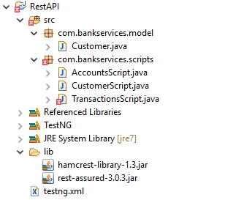

REST API Project consists of **com.bankservices.model and com.bankservices.scripts** package which has following java files for each page.

1. c**om.anzmortgage.scripts** which has Actual Test scripts of the test cases which are TestNG classes. These java files are the runner files which has **@BeforeClass**

***@BeforeClass*** contains initial setup which will be executed every time before every TestNG class.

***@Test*** methods are the actual test cases.

4) testng.xml consists of all the test scripts as **packagename.className.**

Run **testng.xml as TestNG suite** to execute the test scripts. Default report will be generated in the test-output folder.